PHASE 03: PROJECT DESIGN PHASE
SOLUTION ARCHITECTURE & DATABASE DESIGN

Date | 18 July 2026
Team ID | SB-IBM-2026-07-0012
Project Name | Customer Care Registry System
Maximum Marks | 4 Marks

Project Team Members & Roles:
• Priyanka Degala - Team Lead (PD) - Frontend Developer
• Chandrakala Marri - Member (CM) - Backend Design & QA Testing
• Eswarasai Marre - Member (EM) - Backend Developer
• Triloka Pavani Mandhapati - Member (TPM) - Database Developer
• Santhosh Nikhil Moka - Member (SNM) - Fullstack Feature Developer

Solution Architecture Diagram:
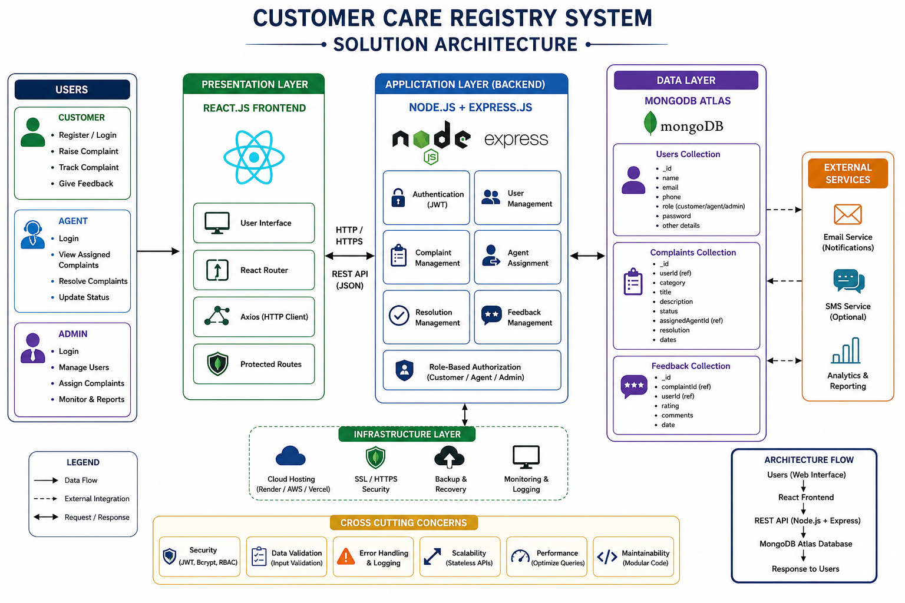

1. System Architecture
The CCRS utilizes a standard 3-tier enterprise architecture:
- Presentation Layer (Vite React Client): Manages routing, handles local state, and renders responsive dashboards.
- Logic Layer (Node.js/Express.js Server): Enforces role validations (JWT middleware) and processes backend controller logic.
- Data Layer (MongoDB Atlas NoSQL Store): Persists structured, flexible document collections.
2. Database Design (Entity Schemas)
The following details the primary database collections and schema definitions used in MongoDB:
User Schema
name: { type: String, required: true },
email: { type: String, required: true, unique: true },
password: { type: String, required: true },
role: { type: String, enum: ['customer', 'agent', 'admin'], default: 'customer' },
phone: { type: String },
photo: { type: String }, // path to profile photo
customFields: { type: Map, of: String } // dynamic fields values
Complaint Schema
title: { type: String, required: true },
description: { type: String, required: true },
category: { type: String, required: true },
priority: { type: String, enum: ['low', 'medium', 'high'], default: 'medium' },
status: { type: String, enum: ['pending', 'assigned', 'in-progress', 'resolved', 'closed'], default: 'pending' },
customerId: { type: mongoose.Schema.Types.ObjectId, ref: 'User', required: true },
assignedAgentId: { type: mongoose.Schema.Types.ObjectId, ref: 'User' },
attachments: [{ type: String }], // file paths
resolutionNotes: { type: String },
customFieldAnswers: { type: Map, of: String }
3. UML Diagrams Outlines
3.1 Use Case Diagram
Maps user processes: Customer (Registers, Logs In, Raises Tickets, Chats, Rates Resolutions); Agent (Logs In, Reviews Assigned Tickets, Writes Resolutions); Admin (Assigns Tickets, Configures Fields, Views Reports).
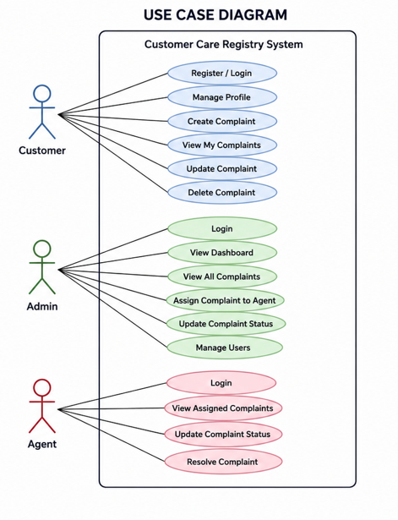
3.2 Sequence Diagram: Authentication Flow
1. Client sends credentials via POST /api/auth/login.
2. Express Router receives request and triggers Authentication Controller.
3. Controller queries MongoDB Atlas Users collection.
4. Users database returns record; controller verifies password hashing via bcryptjs.
5. Success: Controller creates JWT payload and sends signed token back to client.
